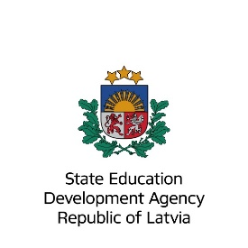

TCA thematic seminar “Erasmus+ promoting physical activity and cooperation in education and training”

06/05/2023 – 09/05/2023

tbc

(Riga, Latvia)

Agenda (draft)

Day 1
(Saturday, 06.05.2023)
 | Arrival and registration
19:00 | Welcome  Dinner and social program
Day 2
(Sunday, 07.05.2023)
9:30 – 12:00 | Introduction
 | From theory to practice: preparing for the marathon
12:30- 13:30 | Light Lunch
13:30 – 14:30 | Warm-up activities
14:30 – | Running the 5 km distance at the Rimi Riga marathon
 | Marathon follow-up
18:00 – 20:00 | Inspiring lecture and joint activity
20:00 | Dinner
Day 3
(Monday, 08.05.2023)
9:00 – 9:45 | tbc  Introduction to the topic
9:45 – 10:15 | tbc, EAC  EU Sports policy and goals – instruments and initiatives to promote healthy lifestyle
10:15 – 10:30 | tbc, State Education Development Agency  Erasmus+ as a framework to promote physical activity and cooperation
10:30 – 11:00 | Coffee break
11:00 – 12:30 | tbc  Parallel sessions -  Identifying sectoral challenges and finding solutions
12:30 – 13:30 | Lunch
13:30 – 14:15 | Panel discussion
14:15 – 15:15 | Practice examples: presentations of various initiatives and projects to support cooperation in Education and Sport
15:15 – 15:45 | Coffee break
15:45 – 16:30 | tbc  Presentation of Erasmus+ programme for cooperation and mobility
16:30 – 17:00 | Closing of the seminar
 | Farewell dinner
Day 4
(Tuesday, 09.05.2023)
 | Departure of participants

*Event moderators: Rasa Lazdiņa and Lauma Žubule
** Please note that during the event photographs will be taken for publicity purposes
***After the event we will share the presentations and list and contact information of the participants

Book places: until 24.02.2023.

Application:

Start date of activity application: 22.02.2023.
Application deadline: 24.03.2023.
Confirmation deadline for Sending NAs: 03.04.2023.
Confirmation deadline for Organiser NAs: 04.04.2023.

